January 1, 2017

Dear Prospective Member:

Thank you for your interest in the Michigan Creditors Bar Association as an Associate Member. We hope that you will begin your membership with MCBA today and help keep our association strong and involved.

Benefits of Membership in MCBA:

- Listing on MCBA website, showing classification of service/product
- Discount member prices on membership meetings, conferences and events
- Special sponsorship opportunities
- Exposure to the largest creditors rights firms in Michigan

Please complete the enclosed Associate Member Profile form and the Dues Payment form and return them either by mail to MCBA, 416 South Cedar Street, Suite C, Lansing, MI 48912, email at michigancreditorsbar@gmail.com or by fax to 866-298-2115.

Thank you for your interest! If you have any questions or need assistance, please feel free to contact me directly at rwwarner@rwwarnerpc.com or contact Maryellen Jansen at the MCBA business office at 517-319-0342 or michigancreditorsbar@gmail.com.

Sincerely,

Robert W. Warner

President, MCBA

Enclosures

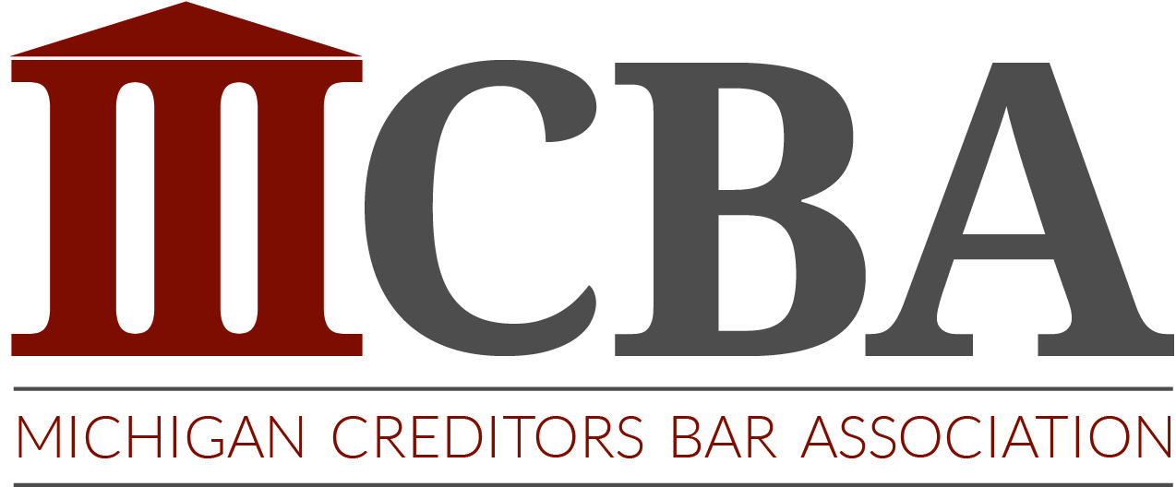

Associate Membership Profile

Associate Member Profile
Name of Law Firm
(if you work for a company that is not a law firm , please indicate)
Primary Contact
Street Address
Mailing Address
(If different than above)
Phone Number
E-Mail Address
Web Site Address
Cell Phone Number
Describe your service/ product (50 words or less)
Territory Covered

Classification of Your Service/ Product (circle all that apply):

Court Officer Court Clerk
Appearance Counsel Process Server Payment Services
Debt Buyer Financial Institution Insurance Agency
Other: ______________________________________________________

Additional staff members included in firm membership:

If you would like to add any additional members from your firm to your membership, please include their contact information here. Please update or correct current members.
First Name | Last Name | E-mail | Phone

Associate Member Dues Payment Form and Certification

Company Name: _______________________________________________

Current Membership Classification: Associate

2017 Membership Dues for the year January 1, 2017 – December 31, 2017 | $175.00
Total Amount Due | $175.00

(MCBA dues and assessments are not deductible as a charitable contribution for Federal Income Tax purposes, but may be deductible under other provisions of the IRS Code.)

Payment Options:
Check payments:
Payable to: MCBA
Remit to: MCBA, 416 South Cedar Street, Suite C, Lansing, MI 48912

Credit Card Payments:
I authorize MCBA to charge the credit card below for a one-time charge of $_____________________, which includes my membership dues and a $6.00 convenience fee.

Please circle one: AmEx MasterCard Visa

Card Number: _____________________________________________________ Exp. Date _____/______

Cardholder Name: _________________________________________________________________

Signature: ________________________________________________________________________

Please submit this form and your associate member profile form either by mail to MCBA, 416 South Cedar Street, Suite C, Lansing, MI 48912, by fax to 866-298-2115, or by email to michigancreditorsbar@gmail.com.

Certification of Membership: We agree to be bound by the rules of the Association as established by the MCBA bylaws.

Print name: __________________________________________________________

Signed Date

