January 1, 2017

Dear Prospective Member,

Thank you for your interest in the Michigan Creditors Bar Association. We hope that you decide to commit to your practice and profession by beginning your firm’s membership with MCBA today and help keep our association strong, vigilant and involved.

Enclosed you will find the items necessary to complete your firm’s membership for 2017:

- Firm Membership Profile: This is the information MCBA holds in its membership database for your firm.
- Dues Renewal Worksheet: Your 2017 dues are calculated based upon the information you provide. If you have any questions, contact Maryellen Jansen at the MCBA business office at 517-319-0342 or michigancreditorsbar@gmail.com.
- Certification of Qualification for Law Firm Membership: Return signed form with your membership dues.
- Permission to Email statement: Please check your preference.
- Areas of Practice: Please check all that apply.

Please complete the above listed items and return via mail to MCBA, 416 South Cedar Street, Suite C, Lansing, MI 48912, via email at michigancreditorsbar@gmail.com or by fax to 866-298-2115.

Thank you for your support! If you have any questions or need assistance, please feel free to contact me directly at rwwarner@rwwarnerpc.com, or contact Association Manager Maryellen Jansen at michigancreditorsbar@gmail.com or 517-319-0342.

Sincerely,

Robert W. Warner

President, MCBA

Enclosures

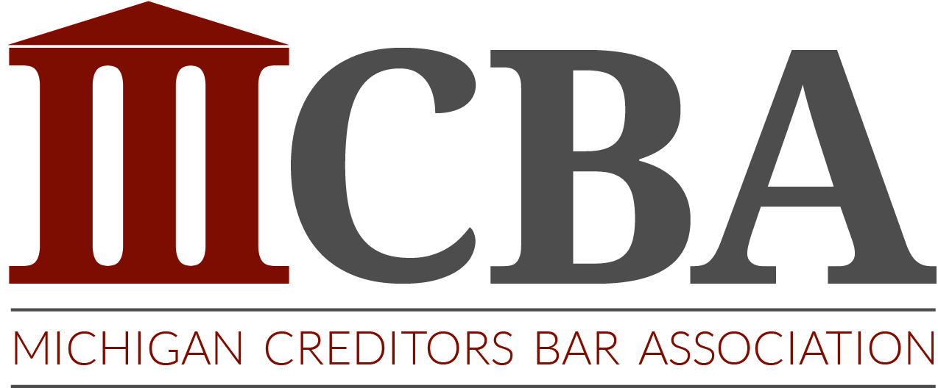
FIRM MEMBERSHIP PROFILE

Name of Law Firm
(if you work for a company that is not a law firm , please indicate)
Principal Attorney
Street Address
Mailing Address
(If different than above)
Phone Number
E-Mail Address
Web Site Address
Cell Phone Number

Additional staff members included in firm membership:

First Name | Last Name | E-mail | Phone
If you would like to add any additional members from your firm to your membership, please include their contact information here. Correct above information as needed.
Benefits of Membership in MCBA:
Sustaining Members
- Recognition at all MCBA events and on MCBA website as a Sustaining Member of the association.
- Plus all Full Member Benefits
Full Members
- Listing under Member Directory index available to creditors and the public
- MCBA governmental affairs updates and member alerts
- List Serve access
- Brief Bank access
- Access to FAQ’s for Judgement Lien Law
- Discount member prices on membership meetings and educational seminars
- Full voting rights
- Access to directories for appearance counsel and court officers / process servers
Consider upgrading your membership to a Sustaining Membership today. Contact Robert Warner, MCBA President at rwwarner@rwwarnerpc.com for more details.

DUES RENEWAL WORKSHEET

Firm Name: ___________________________________________

Membership Classification (based on chart below):
2017 Membership Dues for the year  January 1, 2017 – December 31, 2017 | $225.00
2017 Government Affairs Assessment*
See below to calculate amount
Total Amount Due

(MCBA dues and assessments are not deductible as a charitable contribution for Federal Income Tax purposes, but may be deductible under other provisions of the IRS Code. Government Affairs Assessment Fees may not be deductible as a business expense under the IRS Code.)

Payment Options:
Check payments:
Payable to: MCBA
Remit to: MCBA, 416 South Cedar Street, Suite C, Lansing, MI 48912

Credit Card Payments:
I authorize MCBA to charge the credit card below for a one-time charge of $____________________ , which includes my dues plus a $25.00 convenience fee for credit card payments.

Please circle one: AmEx MasterCard Visa

Card Number: _____________________________________________________________________ Exp. Date _____/______

Cardholder Name: _________________________________________________________________

Signature: ________________________________________________________________________

*MCBA Membership dues are $225.00 per year, plus a Government Affairs Assessment (GAA) fee. The GAA fee is determined by the gross revenue from collections for your firm and/or the number of employees handling collections. This information will NOT be shared with the public as part of your membership profile.

GAA Fee | Firm Gross Revenue from Collections | Number of Employees  Handling Collections
Small Firms: $100.00 annually | Less than or equal to $1 Million | Less than 10
Large Firms: $375.00 annually | Greater than $1 Million | Equal to or greater than 10
Sustaining Firms: $2,325.00 | N/A | N/A
Government Affairs Assessment Fees may not be deductible as a business expense under the IRS Code.

Please submit the signed renewal application and completely membership profile either by mail to MCBA, 416 South Cedar Street, Suite C, Lansing, MI 48912, by fax to 866-298-2115, or by email to michigancreditorsbar@gmail.com.

QUALIFICATIONS FOR LAW FIRM MEMBERSHIP

Any law firm engaged in the active practice of creditors law, including solo practitioners, shall be eligible to be a member of the Association provided that the following qualifications are met:

- All LAW FIRM MEMBER individuals employed as practicing attorneys must be admitted to and in good standing with the State Bar of Michigan.
- At least one attorney of the LAW FIRM MEMBER must devote a significant portion of his/her legal time 1) to the representation of creditors in the field of creditors rights law or 2) related to the practice of creditors rights law.
- Excluded from membership are those attorneys who represent consumer(s) in consumer protection actions against a LAW FIRM MEMBER for state or federal laws protecting consumers related to creditors rights.
- Members are strongly discouraged from defending consumer(s) in collection actions. Excluded from membership are those attorneys who regularly or systematically represent consumer(s) in collection actions. Systematic representation is defined as those who advertise that they represent consumers and/or devote a significant portion of their practice to the representation of consumers in defense of collection actions.
- All LAW FIRM MEMBER applicants must have a business listing in the telephone directory and operate from an established business name and office address. If a P.O. Box is used for the delivery of mail, the members must also supply a physical address. A telephone answering service or telephone call forwarding service or device shall not be considered as an established office.
- All LAW FIRM MEMBER applicants shall agree during the full period of membership, to abide by all written policies of the Association.
- All requirements of the MCBA Bylaws shall continue to be applicable to members during the entire term of their membership.

CERTIFICATION OF QUALIFICATION FOR LAW FIRM MEMBERSHIP

In consideration of the acceptance of this firm’s renewal certification and the approval of our membership in MCBA, we agree to be bound by the rules of the association as established by the MCBA bylaws, a copy of which are attached. Upon acceptance, we grant permission for MCBA to provide our firm name and profile to potential clients seeking legal assistance in the areas we indicate. We further agree that we shall hold MCBA harmless and defend them against any claim against them because of our acts or failure to act, or for any other reason arising out of our membership in MCBA. Further we agree to pay any expenses, costs and attorneys’ fees in connection with the defense thereof and will indemnify or pay any judgment rendered against MCBA arising out of said actions.

Firm Name: ____________________________________________

I, ________________________________, as a principal of the above named firm, certify that the information listed is true and correct; and agree to the conditions stated herein.

Signature of Firm Principal_________________________________ Date: _________________

Firm Name: ____________________________________________

PERMISSION TO EMAIL

Periodically the Michigan Creditors Bar Association (MCBA) will send email notifications informing members of upcoming events, newsletters, member alerts, questions or input from other members. These notifications may come from bulk mail services similar to Constant Contact. By agreeing to receive these emails, the MCBA assures members that their contact information will remain confidential and never be shared with or distributed to any other group or association. Members may unsubscribe from these services at any time.

We agree to receive email notification We do not want MCBA to email our firm notifications

AREAS OF PRACTICE

THE FOLLOWING INFORMATION WILL BE PLACED ON THE MCBA WEBSITE UNDER THE MEMBERS DIRECTORYAND BE AVAILABLE TO CREDITORS AND GENERAL PUBLIC.

Area(s) of practice:
( ) Not accepting new clients at this time ( ) Child support
( ) Credit Card ( ) Insurance subrogation
( ) Installment loans ( ) Commercial claims
( ) Medical debt ( ) Judgment enforcement
( ) Automobile deficiency ( ) Repossession
( ) Retail debt ( ) Professional fees
( ) Creditors’ rights in bankruptcy ( ) Other ______________________
( ) Appearance Counsel _______________________________

Area(s) of service:
( ) Entire state of Michigan
( ) Designated counties only – list below:

______________________________________ ______________________________________

______________________________________ ______________________________________

______________________________________ ______________________________________

